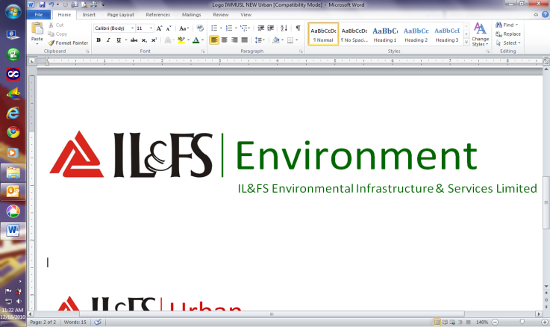

IEISL - Spatial Solution Division

**System Requirement Specification (SRS)**

**Template Version No. 1.2 Effective Date: 23rd Jan 2017**

|  |  |  |  |  |
| --- | --- | --- | --- | --- |
| **Authored by** | **Verified by** | **Validated by** | **Approved by** | **Remarks** |
| EPG team | Review team | Open House Discussion | Divisional Head-SSD |  |
| 16th Feb 2016 | 8th Aug 2016 | 8th Aug 2016 | 23rd Jan 2017 | For version 1.2 only |

|  |  |
| --- | --- |
| **Project Name:** | Technical Services for Development of New Modules and Enhancement of Existing Modules of Forest Management and Decision Support System (FMDSS) with Operation & Maintenance for one Year - FMDSS (Crack) |
| **Project Code:** |  |
| **Document Nature:** | *<Internal Circulation/External circulation/confidential>* |
| **Intended User** | *<Software Developers, Data Developer, Project Managers, Project Management Unit,Business Development, Project Team and project stakeholders>* |
| **Last Updated Date:** | 21-Aug-2017 |
| **Document Status:** | Draft |
| **Document Creation Date:** | 8-Aug-2017 |
| **Author:** | IEISL Team |
| **Reviewer(s):** | IEISL Review Team |
| **Approver:** | IEISL Approver Team |
| **Document Reference:** | RFP , Project Charter ,Requirement Gathering |

This document and the data disclosed herein is confidential & proprietary and is not to be reproduced, used or disclosed in whole or in part to anyone without written authorization from “IEISL”

**Change History**

A-Addition, M- Modification, D- Deletion

| **Revision No.** | **Date** | **Change Mode (A/M/D)** | **Description** | **Reason for Change** |
| --- | --- | --- | --- | --- |
| 1.0 | 21-Aug-17 | A | Draft |  |
|  |  |  |  |  |
|  |  |  |  |  |

**Reviews and Approval**

Reviewers

|  |  |  |  |  |  |
| --- | --- | --- | --- | --- | --- |
| Name | Role | Status | Comments | Version Reviewed | Date |
| IEISL Review team |  |  |  |  |  |

Approvers

|  |  |  |  |  |  |
| --- | --- | --- | --- | --- | --- |
| Name | Role | Status | Comments | Version Approved | Date |
| IEISL Approver team |  |  |  |  |  |

Table Of Contents

1. Introduction 4

**1.1** **Scope of the Document** 4

**1.2** **Literature Review** 4

**1.3** **References** 4

2. Process Workflow 5

3. Methodology Requirement 5

4. System Software Requirements 6

**4.1** **Software Architecture** 6

**4.2** **Module Functionality** 9

**4.3** **Operational Requirements** 50

**4.4** **Software Quality Attributes** 52

**4.5** **Non-Functional Requirements** 52

**4.6** **Scalability Requirements** 52

**4.7** **External Interfaces** 52

**4.7.1** **User Interfaces** 52

**4.7.2** **Hardware Interfaces** 52

**4.7.3** **Software Interfaces** 53

**4.7.4** **Communications Interfaces** 53

5. System Data Requirements 55

**5.1** **Data Module Requirement** 56

**5.2** **Data Architecture** 56

**5.3** **Operational Requirements** 56

**5.4** **Data Quality Attributes** 56

**5.5** **Non-Functional Requirements** 56

**5.6** **Scalability Options** 57

6. System Service Requirements 57

7. Usage Concept 57

**7.1** **User Roles** 57

**7.2** **Use Case 1. <Name>** 57

8. Miscellaneous Requirements 58

9. Exclusions NA 58

**9.1** **<Requirement 1>** 58

10. Assumptions and Dependencies 59

11. To Be Determined List 59

12. Appendix 59

13. Glossary 59

# Introduction

## **Scope of the Document**

<Provide a short description of the overall requirement of the customer in terms of software, data and service. Describe the need, context, and rationale for the system. Discuss how it fits into the overall business or strategic objectives of the customer organization. >

The scope of project work involves:

1. Study, Design , Development & Testing Phase for the following components:
   * Development of new modules of FMDSS as per the requirement of RISL
   * Integration possibilities with following third party applications/ systems in DOIT&C / RISL
     + RAJDHARAA – State Wide Unified GIS platform for the State of Rajasthan.
     + GIS map with GPS system to be provided by Government of Rajasthan
     + Mobile Service delivery gateway (SMS gateway)
     + SSO
     + RAAS
     + Stateportal
     + CM Dashboards
     + Various analytical tools (SAS etc.)
     + Rajnet
     + State Data Centre
     + Raj e-sewadwar
     + E-Office
     + Wildlife Surveillance & Anti-Poaching System
   * Implementation and Support
   * Training and Capacity Building as and when requiredand provide training for new modules and enhanced functionalities to the master trainers.
2. Operations & Maintenance and Support for the period of 12 months from the date of Go-live of new modules.

## **Literature Review**

<Summarize the major documents reviewed as secondary source of information during preparation of this SRS document. This may include research notes, thesis, manuals, books, magazines, articles, etc.>

Visited different website of the Forest department and the view the scanned document provided by forest department.

## **References**

<List any other document or web address to which this document refers for Software, Data and Service requirement. These may include user interface style guides, contracts, standards, use case documents, or a vision and scope document.>

A lot of reference has been taken from the input received from Forest Department in form of formats currently being used.

# Process Workflow

*<If section not applicable, indicate so and provide a reason. >*

*<Define the integrated project workflow with all process steps keeping software, data and service with the help of a project workflow diagram.>*

***Note****:* Please refer the flow diagrams of individual models in respective sections.

# Methodology Requirement

*<If section not applicable, indicate so and provide a reason>*

*<Define high level methods and methodology including specific technical aspects applicable for software, data and service. This shall also include specific methodology, technical models, design standards for planning, designing & development and support & service phase. Example: High Level Data Model, Calibrations and Standardizations, Quality Standards, Monitoring and Testing, Complain Handling, SLA etc. The detailed aspects shall be described in respective sections of software, data and service.>*

Software Development Lifecycle which needs to be followed is described as under:

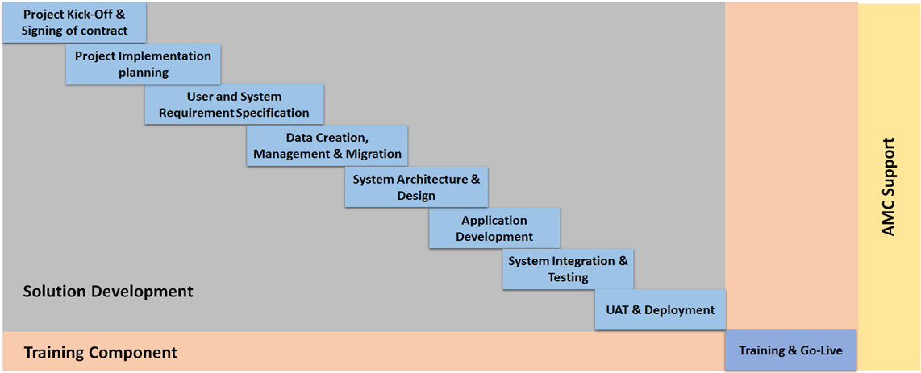

MVC (Model – View – Controller) Framework – Version 4.0

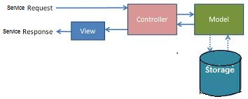

# System Software Requirements

*<If section not applicable, indicate so and provide a reason.>*

<This section covers detailed system requirement study of software development.>

|  |  |
| --- | --- |
| User Characteristics | *<Type of user and user’s roles and rights etc.>*  Users of Forest Department at following hierarchy:   * PCCF * CCF * Division Officer * Range Officer * Field Level/JFMC   Citizens/ public users are also part of user group |
| Operating Environment | *<.NET based, Window based, Open Source based etc.>*  ASP .Net MVC architecture with WCF service based integration |
| Design Constraints (if any) | *<Out of box requirement not supported by COTS.>* |
| User Documentation | *<software related client documentation like: architecture document, MVC, SOA etc.>* |
| *<Any Other>* |  |

## **Software Architecture**

*<If section not applicable, indicate so and provide a reason>*

<Specify architectural requirement for software development like framework, design related aspects, database structure etc. Define an overall solution architecture diagram including all hardware, software and networking component. Also elaborate the networking diagram of the overall solution, location wise (in case required).>

Technical architecture for requirement shall be as follows:

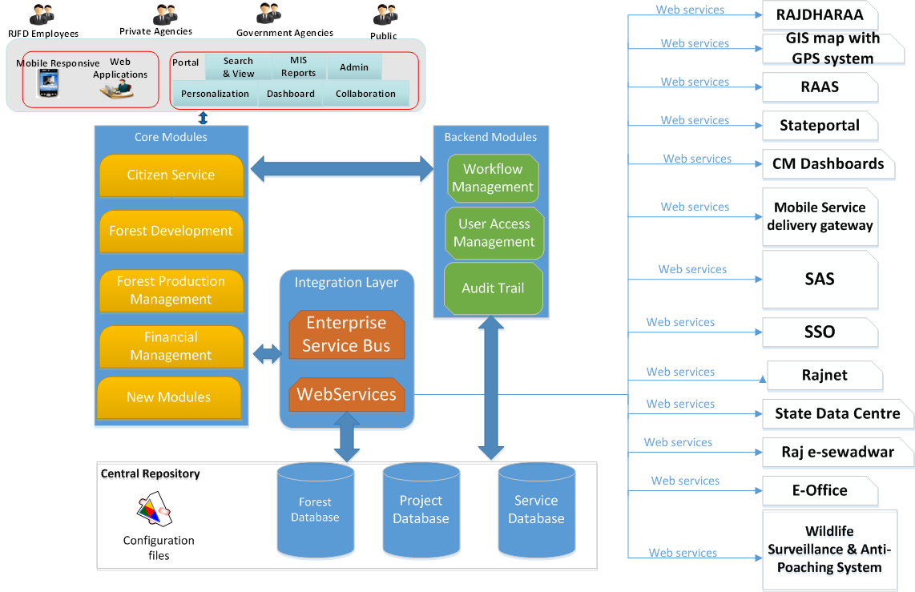

Figure: Indicated Solution Architecture of FMDSS

The solution architecture defines the system which comprises of Data Layer, Business Layer, Service Layer, Presentation Layer and various clients accessing the application.

* **Central Repositories Layer:** This aspect of the solution addresses the different type of forest documents, photos, survey reports, and master data. Metadata repository to store metadata for each of the thematic datasets. The data layer ensures that all the required information/data is collected, collated and converted to integrated data model. This also store services related data set
* **Application Layer:** Enables seamless access to metadata and data access layer with use of business logic requirement store, retrieve information. This access backend module and represented to core module.
* **Integration Layer:** It is envisaged service working at RISL to be seamlessly integrated for fulfilling the functionality and disseminating information available from different source as point to point basis. This integration layer consists of ESB and web services to cater the functionality requirement.
* **Enterprise Services Bus**: Typically covers all of the middleware services for all FDMSS core module as SOA orchestration and business collaboration between the different departments within / outside of RISL on a requirement basis. This primary exposed service which need to be required as consumed directly or to be required by presentation layer.
* **Presentation**: It is to enable different categories of users both internal and external to successfully search, personalize MIS report, Dash board FMDSS content over the intranet and internet. The responsive application allow mobile user to access over smart devices.

Architectural Capability

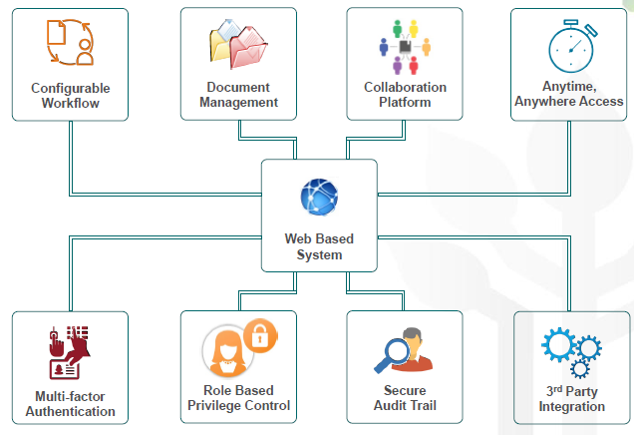

## **Module Functionality**

**<1>: Module Name*:* Forest Right Act [FRA]**

*<Define various modules and web pages, in and out parameters as part of software requirement, technical specifications of the application, various interfaces etc.>*

**Purpose& Scope of Module**

The purpose of this Module is to identify and analyze the requirements for the effective implementation of Forest Rights Act [FRA] Act for Rajasthan State Government. It aims to manage the workflow for approval cycle for forest rights claim process.

The main features included:

* Online claim workflow cycle management,
* Seamless flow of information from one hierarchy to another
* Transparency in the system by giving access to citizen to track the status of claim online.

It can be used by various forest dwellers / citizens who want to claim right on forest land and track it via user friendly interface.

This module is basically an addition to currently working application. Below is the screenshot for Citizen Module for FMDSS application.

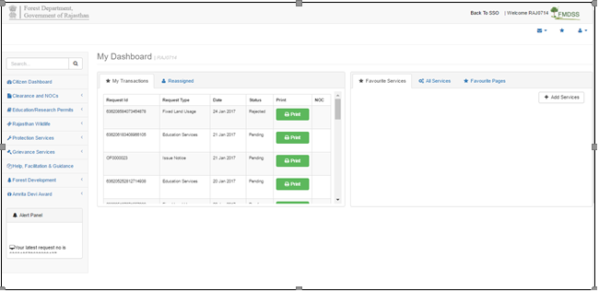

**Perspective of this module:**

Forest Rights Act [FRA] is a landmark legislation to recognize and vest the forest rights and occupation in forest land in Scheduled Tribes and Other Traditional Forest Dwellers.

It provides for framework for recording of rights and extent and nature of evidences for recognition of rights.

The proposed system will address the need to implement FRA in an efficient manner so as to keep all the concerned stakeholders well informed. At the same time, accelerating the approval process by replacing the manual flow of paperwork with digital workflow.

General Hierarchy of FRA implementation is as shown below:

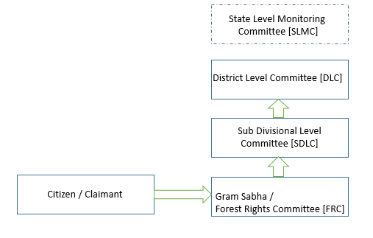

**Workflow Cycle** –

Below Diagram illustrates the workflow cycle for the Forest Rights Claim process that the proposed system should focus on.

On High Level, there will be two six levels of claim process starting from Citizen/ Claimant for the Forest Land. Gram Sabha is the first Authority to review the application. All the approval authorities shall have the privilege to review, re-assign, reject or approve the claim application.

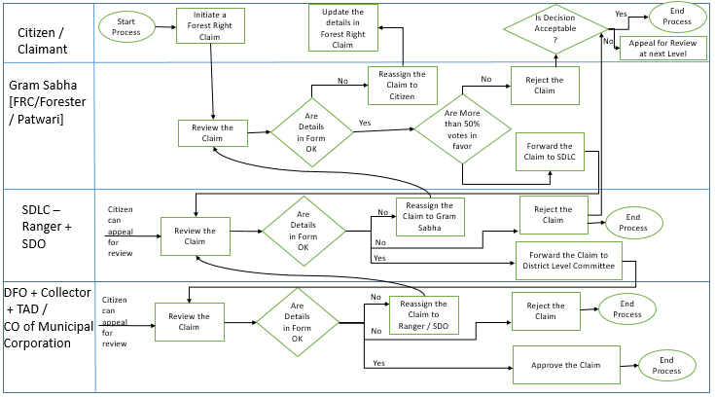

**Functional Requirement of Citizen/Claimant Module:**

Citizen/Claimant shall be initiating a forest right claim via online FMDSS application and submit it to the approving authorities for subsequent approval cycle.

As per Forest Right Act [FRA], Claim rights can be categorized into 3 categories:

* Individual Right – Section 3 (1) (a) right to hold and live in the forest land
* Community Rights
* Section 3 (2) Development Rights (Facilities)

Various Application forms which capture the details of various forest right claims:

Form 1: Claim Form for Rights to Forest Land:

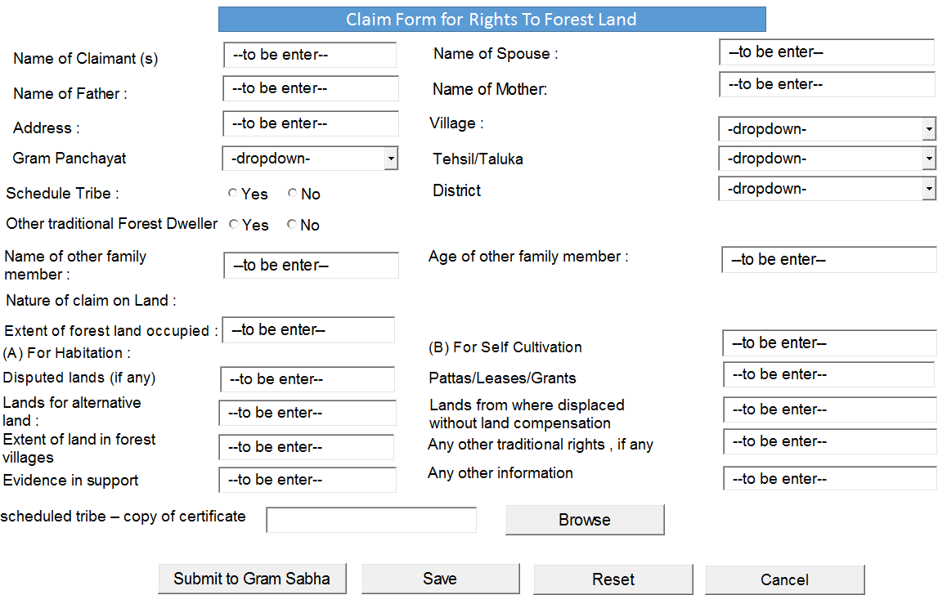

** The declaration part should be automatically taken care by the logged-in SSO user id.

Form 2: Claim for Community Rights

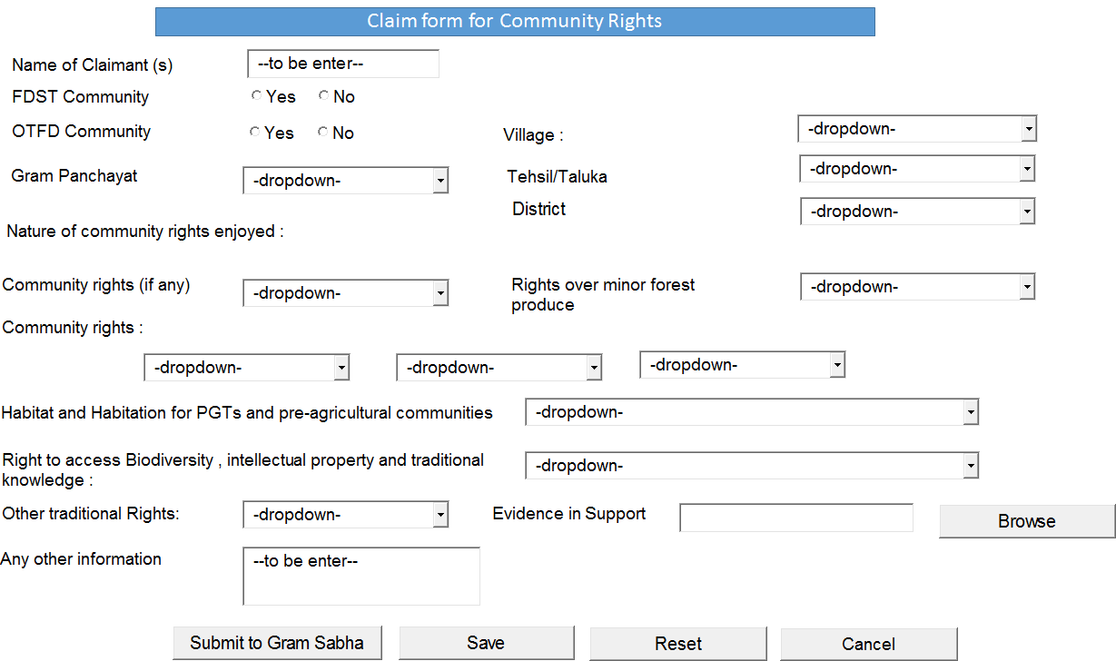

** The declaration part should be automatically taken care by the logged-in SSO user id.

** The source of the drop-down are the master data present in the FMDSS application. Some data is already available in FMDSS application. Left data will be provided by Forest Department.

Form 3: Claims for rights to community forest resource

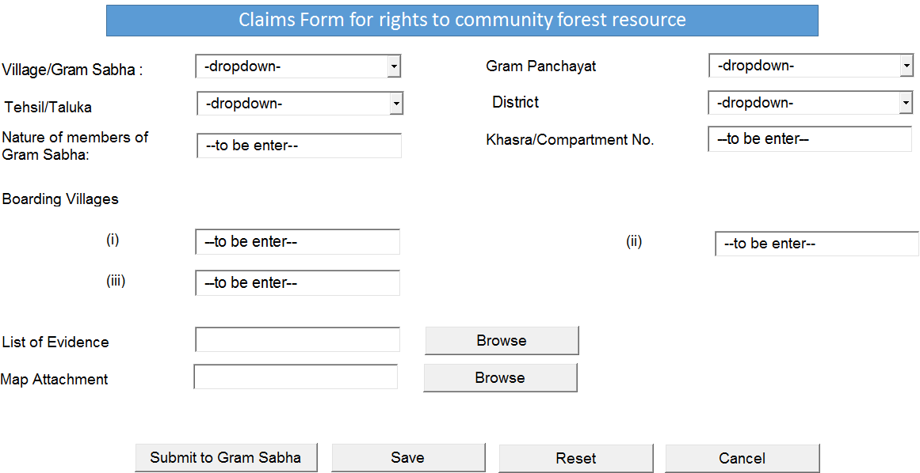

** The declaration part should be automatically taken care by the logged-in SSO user id.

Form 4- Forest Land under Occupation

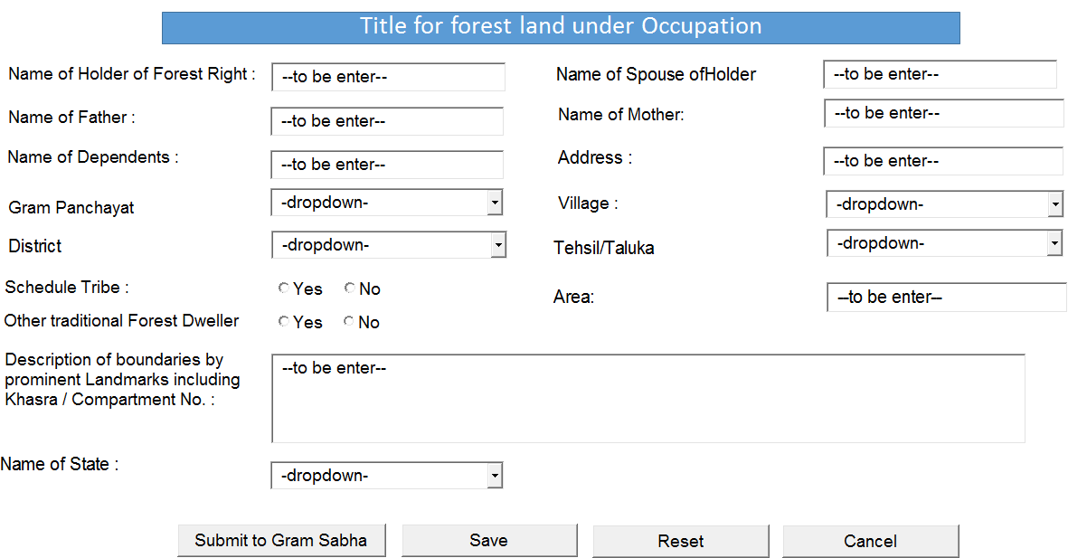

** The declaration part should be automatically taken care by the logged-in SSO user id.

Form 5 – Title to Community Forest Rights

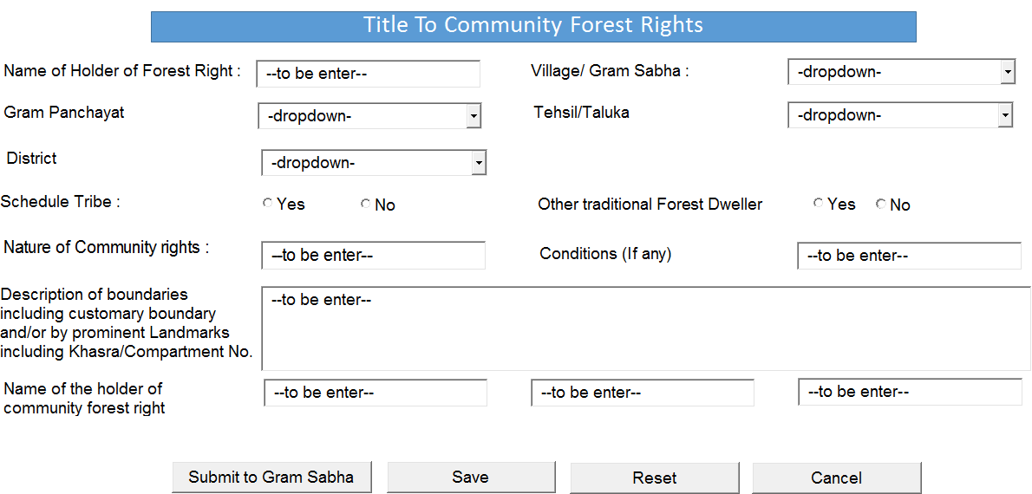

** The declaration part should be automatically taken care by the logged-in SSO user id.

Form 6 – Title to Community Forest Resources

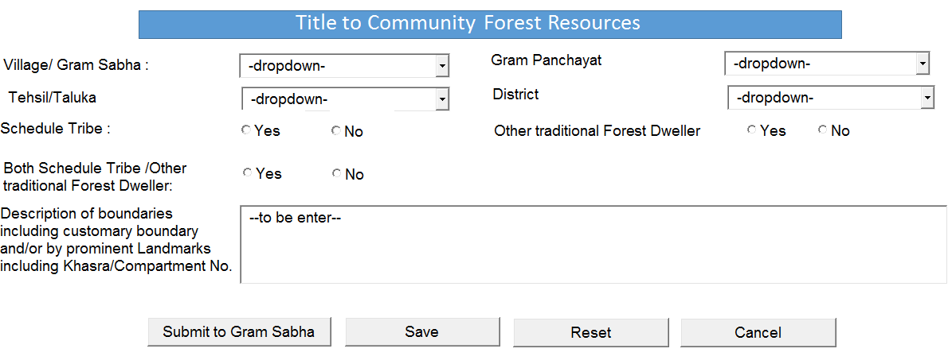

** The declaration part should be automatically taken care by the logged-in SSO user id.

** Both Schedule tribe.. Option is provided to select whether they belong to both category or not.

Functionalities –

* The system shall enable Citizen/Claimant to add one or more forest claim application forms.
* The system shall provide a user friendly interface to enter/select various details required as per above attached formats in an online application form.
* The system shall notify the Citizen/Claimant about any error in the entered details of the configuration.
* The system shall provide the facility to save a partial filled application form that can be worked upon later and then submitted.
* The system shall notify the Citizen/Claimant on successful submission of the application form.
* The system shall send sms /email notifications to the Citizen/Claimant whenever there is a status update on the submitted application form.
* The system shall display all the application forms submitted by the Citizen/Claimant.
* The system shall allow Citizen/Claimant to edit/update the claim application form till it is not submitted for approval.
* The system shall allow user to confirm/cancel the updates.

List View of Citizen Applications –

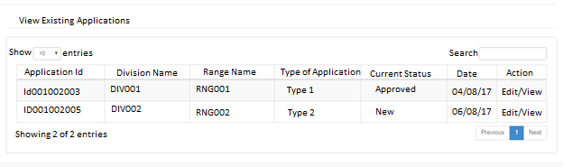

|  |  |
| --- | --- |
| Priority | Mandatory |
| User Characteristics | Citizen User Role – Citizen can access this module through Valid Authentication from the login page.  Review process will be performed by Gram Sabha user , SDLC Ranger , SDO , DFO , Collector etc. |
| Operating Environment | ASP .Net MVC architecture with WCF service based integration |
| Design Constraints (if any) | NA |
| User Documentation | Will be more detailed in Design document and subsequent User Manual. |
| Project Inputs | RFP , Requirement Gathering and Client Interaction |
| Validations | Validation of Login from Citizen User |
| Project Outputs | Web Application with related documentation and User Manual |
| *<Any Other>* | NA |

**Functional Requirement of GramSabha Module-**

Gram Sabha is the next hierarchy in the forest right claim workflow and first authority to authorize the application form.

Based on the information provided by Citizen/Claimant, Gram Sabha reviews the claim application and directs Forest Rights Committee [Members selected among Gram Sabha Members], Forester and Patwari to visit the site and provide the required information/feedback for the claim.

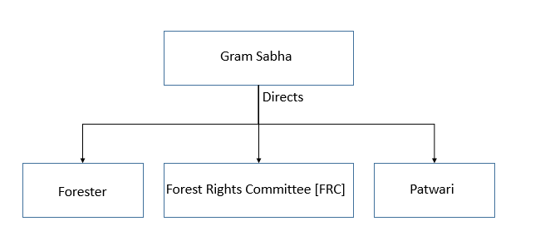Gram Sabha screens the claim application and needs more than 50% of the member votes for forwarding/rejecting the application.

Various privileges available to a Gram Sabha user in the system shall include:

* Review the claim application and submit its remarks/feedback on the claim.
* Re-assign the claim application to Citizen/Claimant for adding more details.
* Reject the claim application and close the claim.
* Forward the claim application to next hierarchy i.e. Sub Divisional Level Committee [SDLC]
* The system shall display all the claim application forms submitted by the Citizen/Claimants for perusal by respective Gram Sabha along with the current status of the application form.
* The system shall enable Gram Sabha user to review and submit remarks/feedback by Forester, FRC and Patwari separately.
* The system shall provide the facility to upload related documents/images that can be recorded and forwarded for the claim application.
* The system shall provide the facility to save a partial filled application form that can be worked upon later and then submitted.
* The system should ensure that a claim application can be re-assigned/forwarded/rejected only after feedback/remarks have been entered for all the 3 authorities at Gram Sabha Level. i.e. FRC, Forester and Patwari.
* The system shall notify the Citizen/Claimant on successful submission of the application form to next hierarchy.
* The system shall allow user to confirm/cancel the updates on a claim application till it is not submitted to the next hierarchy.

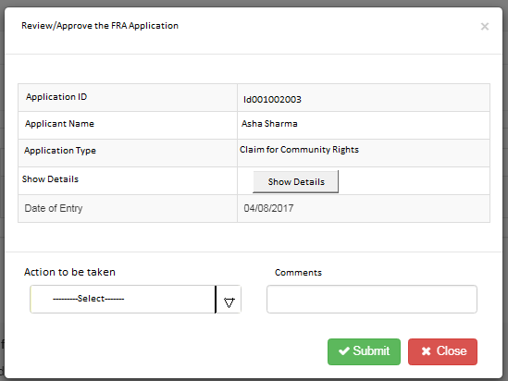

Indicated Screen for Review/Approval of FRA application

Received Application by forester–

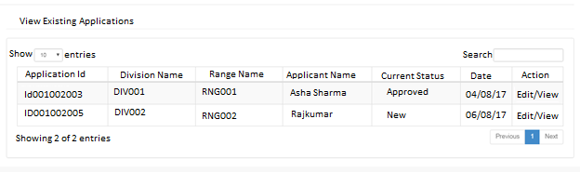

** This view will be applicable to forester only.

**Functional Requirement of SDLC / Ranger and SDO Module-**

Sub Divisional Committee is the second level in the hierarchy in the forest right claim workflow and first authority to authorize the application form.

Ranger and SDO are the deciding authorities at SDLC level. Approval from both Ranger and SDO is required for forwarding the application to next hierarchy.

In a parallel way, Both Ranger and SDO are responsible to review the claim application and provide their respective remarks/feedback and suggest next set of action. i.e. [Re-assign to Forester OR Patwari / Reject the claim application / Forward the claim application].

Both Ranger and SDO users are given below privileges in the system:

* Review the claim application and submit its remarks/feedback on the claim.
* Re-assign the claim application to respective Forester / Patwari for adding more details.
* Reject the claim application and close the claim.
* Forward the claim application to next hierarchy i.e. DFO/ Collector/TAD/CO.
* The system shall display all the claim application forms submitted by Forester/ Patwari users for perusal by respective Ranger and SDO along with current status of the claim application.
* The system shall enable Ranger and SDO users to review and submit its remarks/feedback on the claim.
* The system shall provide the facility to save a partial filled application form that can be worked upon later and then submitted.
* The system shall notify the Ranger and SDO users on successful submission of the application form to next hierarchy.
* The system shall allow user to confirm/cancel the updates on a claim application till it is not submitted to the next hierarchy.

**Functional Requirement of DLC-DFO, Collector, TAD /CO Module-**

Next set of stakeholders in the forest right claim workflow are Divisional Forest Officer [DFO], Collector, Tribal Affairs Department [TAD] OR CO (CO works on behalf of TAD where no TAD committee is available).

All these stakeholders work in parallel way to authorize the application form. However, approval from all the 3 approving authorities is required for approving the forest claim application.

Ranger can forward the application to DFO/ Collector/TAD/CO authorities only after SDO has cleared the claim application for forwarding.

Similarly, SDO can forward the application to DFO/ Collector/TAD/CO authorities only after Ranger has cleared the claim application for forwarding.

In a parallel way, Both Ranger and SDO are responsible to review the claim application and provide their respective remarks/feedback and suggest next set of action. i.e. [Re-assign to Forester OR Patwari / Reject the claim application / Forward the claim application].

All these users are given below privileges in the system:

* Review the claim application and submit its remarks/feedback on the claim.
* Re-assign the claim application to respective Ranger/ SDO for adding more details.
* Reject the claim application and close the claim.
* Approve the claim application in favor of Citizen/Claimant.
* The system shall display all the claim application forms submitted by Ranger/ SDO users for perusal by respective DFO/ Collector/TAD/CO along with current status of the claim application.
* The system shall enable DFO/ Collector/TAD/CO users to review and submit its remarks/feedback on the claim.
* The system shall provide the facility to save a partial filled application form that can be worked upon later and then submitted.
* The system shall notify the DFO/ Collector/TAD/CO users on successful submission of the application form for approval of the claim.
* The system shall allow user to confirm/cancel the updates on a claim application till it is not submitted to the next hierarchy.

**<2>: Module Name*: <Animal Rescue Application>***

The purpose of the module is to identify and analyze the requirements for the online animal rescue application management for Rajasthan State Government. This module aims to manage the workflow for approval cycle for rescue application process.

The main features of this module –

* Raising an animal rescue application by citizen using an online web based system.
* It is also used by citizens/complainants to report rescue application.
* Rescue officials to maintain and keep track of various rescue applications online
* Designated Forest Officials to manage the review and approval of the rescue applications and track the status for the same.

**Workflow Cycle**:

Below Diagram illustrates the workflow cycle for the Animal Rescue Application Management process that the proposed system should focus on.

On High Level, there are three stakeholders namely Citizen/Complainant, Rescue Official and Designation Forest Officer.

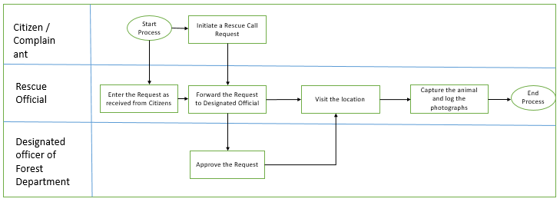

**Functional Requirements – Citizen/Claimant**

Citizen/Claimant shall be initiating an animal rescue application via online FMDSS application and submit it to the rescue official for taking appropriate action.

Below are the major details that need to be captured in the application form for raising a rescue application:

* Registration No
* Name
* Mobile No
* SSO ID
* Fields to be added as per format of registration of rescue officials
* The system shall enable Citizen/Complainant to add one or more animal rescue application forms.
* The system shall provide a user friendly interface to enter/select various details required as per formats for application form.
* The system shall notify the Citizen/Complainant about any error in the entered details of the configuration.
* The system shall provide the facility to save a partial filled application form that can be worked upon later and then submitted.
* The system shall notify the Citizen/ Complainant on successful submission of the application form.
* The system shall send sms /email notifications to the Citizen/ Complainant whenever there is a status update on the submitted application form.
* The system shall display all the application forms submitted by the Citizen/Complainant.
* The system shall allow Citizen/Claimant to edit/update the application form till it is not submitted to rescue official.
* The system shall allow user to confirm/cancel the updates.

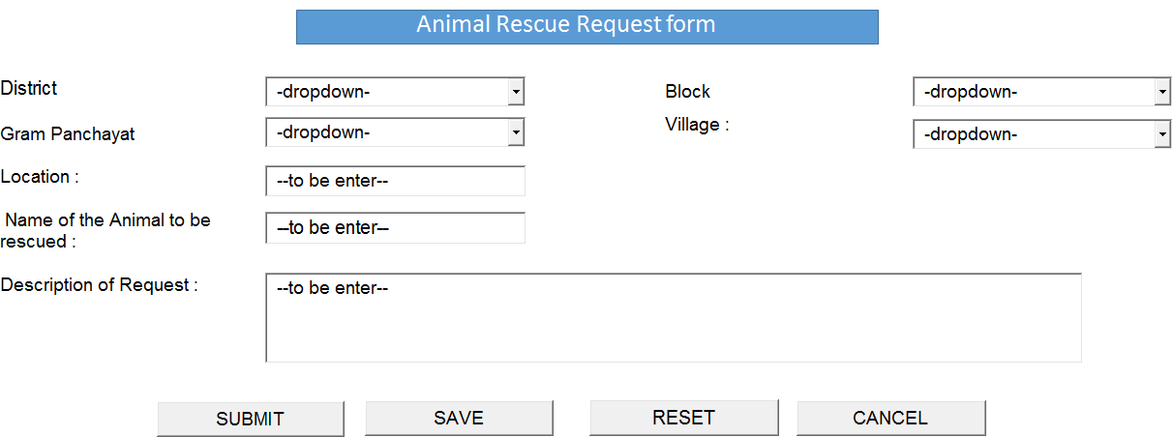Animal Rescue request form by citizen -

* User will select various dropdown to select the place of rescue of the animal.
* User will enter the various information as per the label.
* User can submit the application and the application will be forwarded to the forest officer.
* User can save the application to be submitted later.
* User can also reset/cancel the application.

**Functional Requirements – Rescue Official**

Rescue Official can also initiate a rescue application form based on the inputs received from citizen.

* The system shall enable Rescue Official to add one or more animal rescue application forms.
* The system shall provide a user friendly interface to enter/select various details required as per formats for application form.
* The system shall display all the application forms submitted by the Citizen/Claimants for action to be taken by respective Rescue Official.
* The system shall enable Rescue Official user to review and submit its remarks/feedback on the application.
* The system shall provide the facility to save a partial filled application form that can be worked upon later and then submitted.
* The system shall notify the Citizen/Claimant on successful submission of the application form to Designated Forest Officer.
* While initiating the application, The system shall enable Rescue Official to capture below details for the application:
* Location Details 🡪 Location, Village, GP, Block, District
* Complainant Details 🡪 Name, e-mail ID, Ph. No / Mb. No.
* Animal Details 🡪Animal Name
* There should be facility to upload picture (GO Tagged) in the system along with name of the animal at the time of capturing.
* At the time of capturing (GO tagged Photo Upload, Name of Animal (selection from Drop Down), Radio Buttons (Animal is fit to be translocated in wild and Animal Needs treatment).
* At the time of release (GO tagged Photo Upload at the point where the animal has been released.

**View Existing Application –

* Once the Forest officer (in next heading) will approve the request and assign the rescue officer to this request , then the rescue officials will login in the system and can view the existing application through “View Existing Application Grid view”.
* Forest Officer can search these application through this grid list view.
* Forest officer can view /edit this application.
* Once the application is initially opened, then the rescue official will add details with capture time, where information of the captured animal is entered.
* When animal is finally ready to be released, then the rescue official will add details of releasing the animal.

Add details in Investigation form (with Capture time) –

* As shown, Registration No. , Applicant Details, Location details and Name of the Animal to be rescued are auto populated.
* At the time of capturing of the animal, photos needs to be uploaded regarding the capturing of the animal.
* Radio Buttons (Animal is fit to be translocated in wild and Animal Needs treatment) should be selected.
* User can submit the application or save it for later use.
* System will also allow to reset / cancel the enter details.

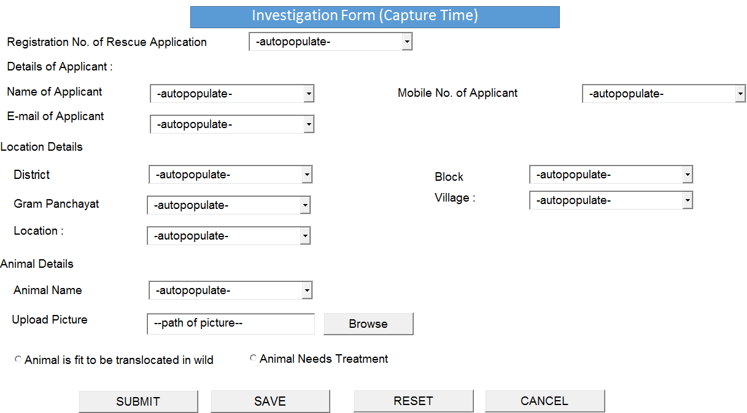

Add details in Investigation form (with Release time):

* At the time of Releasing of the animal, photos needs to be uploaded regarding the release of the animal.
* User can submit the application or save it for later use.
* System will also allow to reset / cancel the enter details.

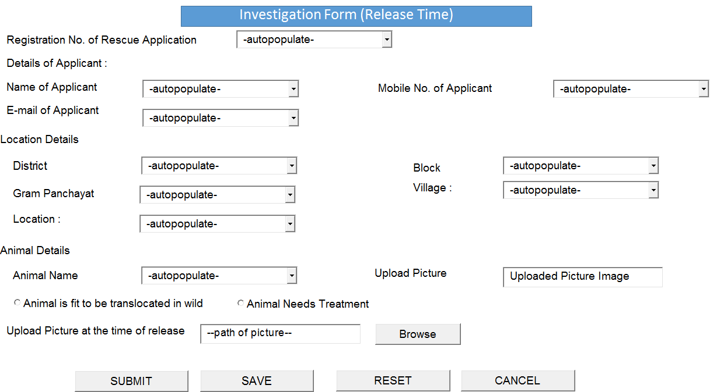

**Functional Requirements – Forest Officer**

Designated Forest Officer is the authorizing authority to approve an animal rescue application.

* The system shall display all the application forms submitted by Rescue Officials for approval to be taken by designated Forest Officer.
* The system shall enable Forest Officer to review and submit its remarks/feedback on the application.
* The system shall provide a user friendly interface to generate various MIS reports from the system.

Assign Investigation officer and approval for the application-

* User will select various dropdown and enter the data as per the requirement of the form.
* User will forward the information to the rescue officials.

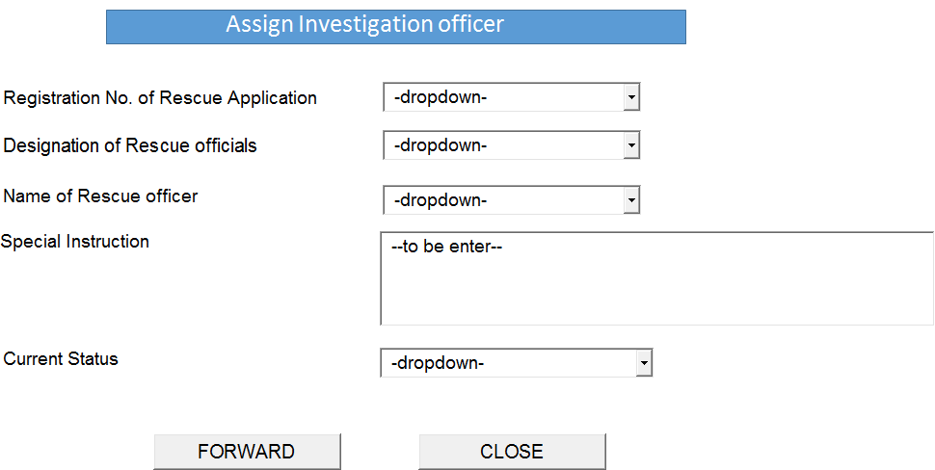

|  |  |
| --- | --- |
| Priority | Mandatory |
| User Characteristics | Citizen , Rescue official , Forest Officer |
| Operating Environment | ASP .Net MVC architecture with WCF service based integration |
| Design Constraints (if any) | NA |
| User Documentation | Will be more detailed in Design document and subsequent User Manual. |
| Project Inputs | RFP , Requirement Gathering and Client Interaction |
| Validations | Validations needs to be implemented as per the page. |
| Project Outputs | Web Application with related documentation and User Manual |
| *<Any Other>* | NA |

**<3>: Module Name*: <Encroachment>***

Encroachment module deals with the Encroachment of forest land in Rajasthan. This module is a sub module of Forest Protection Module and deals with the protection activities that the forest department provide to stop encroachment on the forest land in Rajasthan.

This module provide the right to citizen to apply for encroachment registration online. Citizen can login in the application and enter the details. This will allow the citizen to enter the details to enter the known/unknown information.

Encroachment Registration by Citizen -

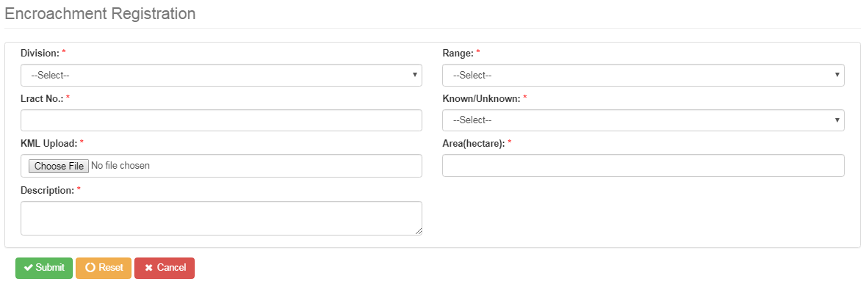A citizen can login in the citizen portal and from the Encroachment Registration page, can apply for the registration of encroachment.

Following are the basic features:

* System will allow the Citizen user to perform the registration for both Known and Unknown Encroacher.
* System will allow the user to upload the KML of the area where encroachment is happening.
* Based on the uploaded KML, Area (hectare) will be populated in the system.
* For the Known encroacher, system will allow information to be filled for e.g. Encroacher Name, his/her Aadhar/Bhamashah details etc.
* System will allow to add details of multiple encroacher for a single encroachment.
* System will also allow to reset / cancel the enter details.
* Once the details are submitted by Citizen, it will be shown at the dashboard of DFO for the respected filled application.
* The system shall provide a user friendly interface to enter/select various details required as per formats for application form.
* The system shall display all the application forms submitted by the Citizen for action to be taken by respective forest Official.
* The system shall notify the Citizen about any error in the entered details of the configuration.
* The system shall notify the Citizen on successful submission of the application form.
* The system shall send sms /email notifications to the Citizen whenever there is a status update on the submitted application form.

Mock Screen in case of Known Encroacher: As displayed below, following are fields that Citizen can fill in case of Known Encroacher – like Encroacher Name, Address, Aadhar/Bhamashah details and finally add multiple encroacher for a single encroachment.

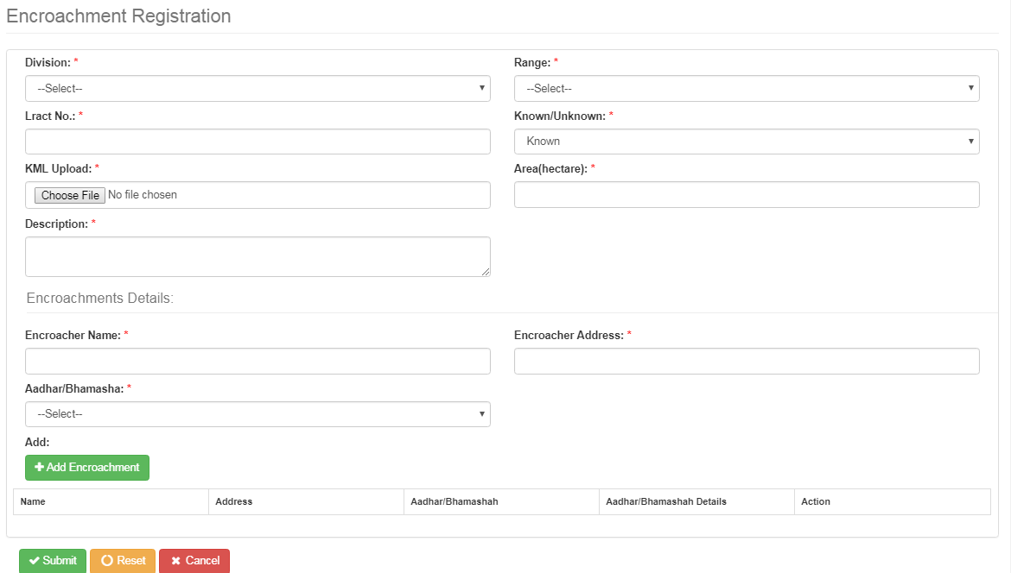

As shown in the below mock screen – a record of encroacher is added and displayed in the grid list.

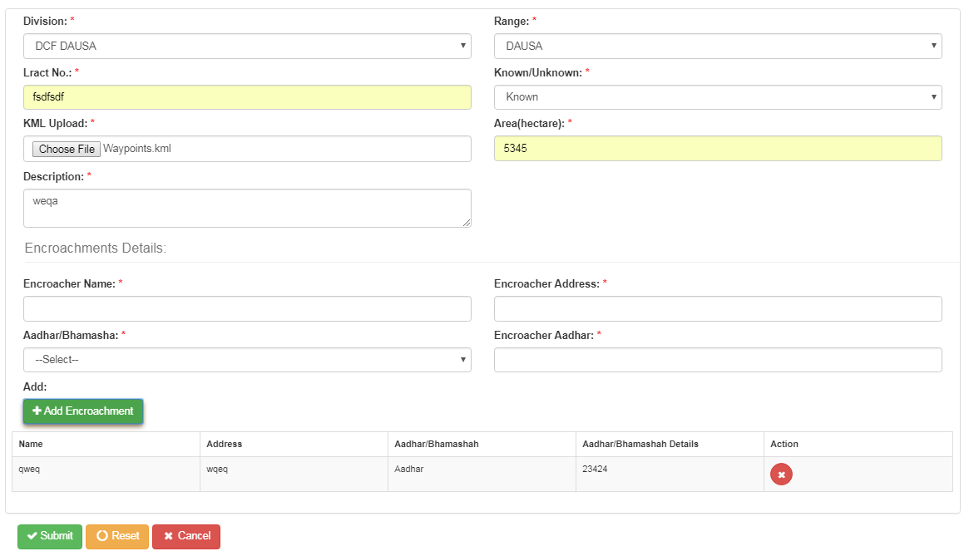

Once the citizen submit the encroachment application, system will generate an encroachment id associated with this encroachment application as displayed below.

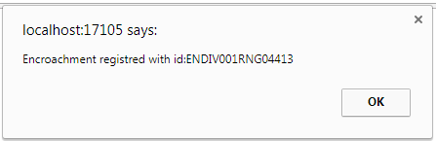

View from Forester (DFO) & Assign to officer:

Once the Application is submitted by Citizen, it will be displayed under the link “Encroachment Assignment” from the DFO login.

* DFO will login in the system and click the link “Encroachment Assignment” to view all the pending application.
* DFO will click the “Assign officer” button to assign the officer.
* DFO can perform search for any application.

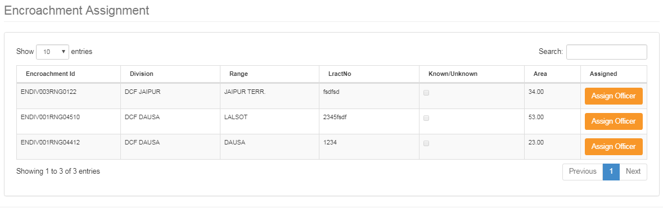

Once the DFO click “Assign officer”button, then the following form window will display, from where DFO can select the officer to be assigned to this encroachment application as displayed below-

* System will allow to choose the investigation officer based on his/her designation. Hence Designation needs to be selected first and based on this filter corresponding names should be displayed under the forest officers list.
* If the DFO wants to add any special instruction, then it can be added under “Special Instruction”.
* Once the above fields are filled, DFO will click forward to forward the application or can also click on cancel to not perform any action on the application.

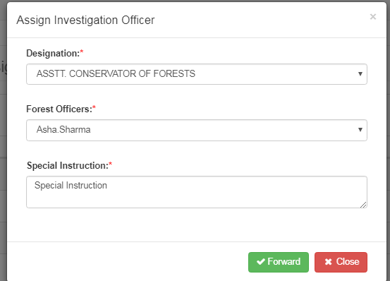

Once the DFO assigned the officer to the encroachment application, then system will generate a message saying “Encroachment is assigned successfully.”

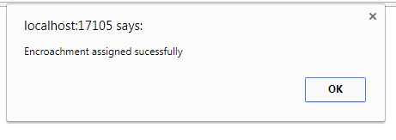

Login from Assigned officer –

* The assigned officer can login in the system and view the existing application of encroachment.
* Assigned officer can add details in the application.
* Assigned officer can search the application in the grid view list.

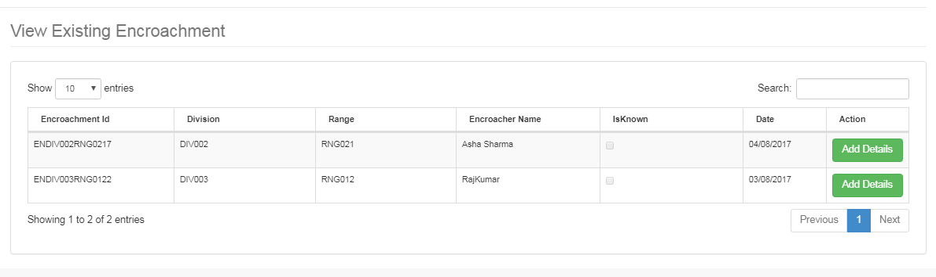

Add details from Assigned officer -

* + Assigned officer based on his investigation can add further details.
  + Information like tax per hectare, Encroachment area, and Encroachment yield will be entered by assigned officer.
  + Information about Encroacher – like his/her name, address, Aadhar/Bhamashah information is entered.
  + Officer can add multiple encroacher details for a single encroachment.
  + System will also allow to reset / cancel the enter details.

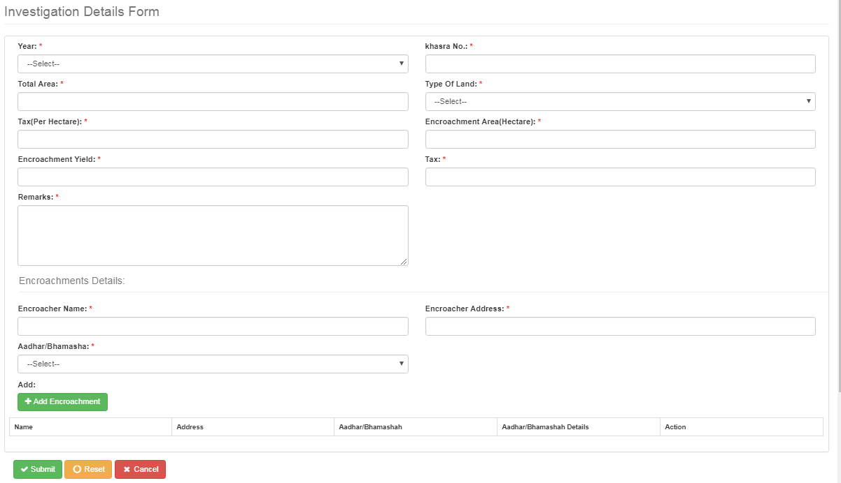

* System now showing the details of the added encroacher details in the grid view.
* System holds this information as a temporary save and will discard this information if the cancel button is clicked.
* System also allow to delete this added information and can add multiple encroacher.
* System will also allow to reset / cancel the enter details.

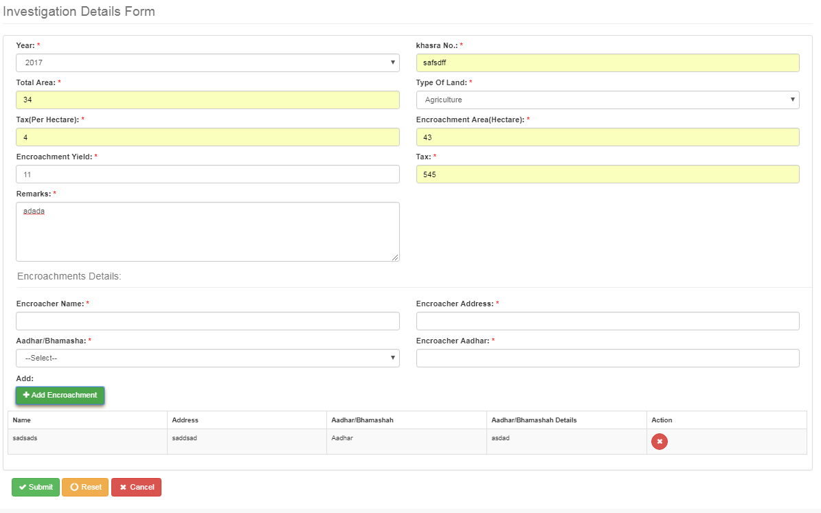

Once the officer submit the application, then system will generate a message that – Investigation details is registered with an id.

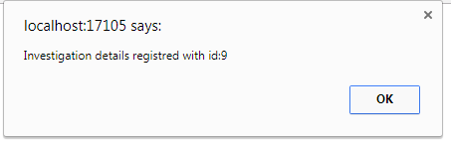

Dispatch –

Assigned officer will login in the system and through the dispatch window, add the dispatch details.

* Assigned officer will go to dispatch grid view and view all the pending application which are yet to be dispatched.
* Once the dispatched details are added, then this encroachment application will be forwarded to the ACF for the respected application.

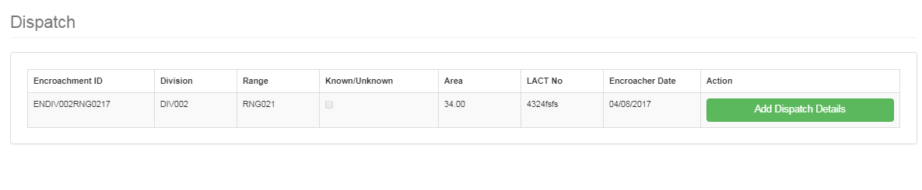

* Click the “Add Dispatch details” button to open “Dispatch details” window.
* Information about the encroachment should be provided to take further action.
* Dispatch no. should be auto generated.
* Dispatch details should be by default the current date which can be changed to future dates and only on the selected future date, this application should be forwarded to the ACF.
* Once the submit button is clicked, then this application should be forwarded to ACF based upon the selected date.

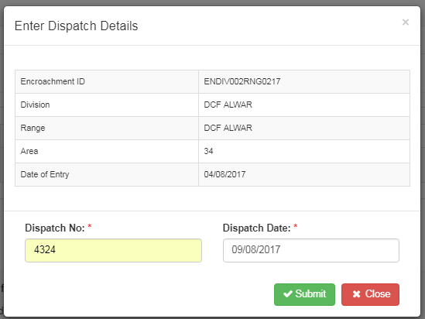

* Once the application is dispatched, then the system should generate a successful dispatch message to user.

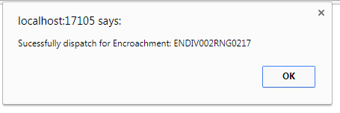

View from ACF

* ACF will login in the system and view the encroachment application from “Encroachment List” view.
* Encroachment List contains the details of Encroachment application like – Encroachment ID, Division, Range, Name of the assigned officer, Date, Dispatch No. , Dispatch Date and Action.
* System will also allow to print the notice generated once the application is approved.

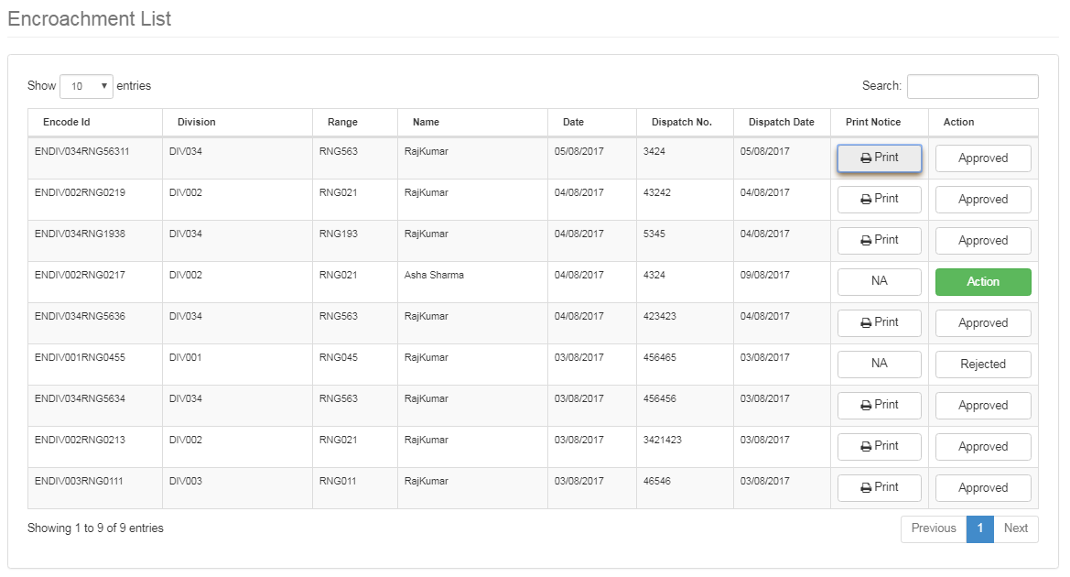

Click an application which comes after dispatch from assigned officer (which is yet to be approved), the following window will display –

* Under the following window, ACF have the right to either approve or reject the application.
* If the application is approved, then system will give an option to generate a notice. The generated notice can be printed from the list view. Approved status of the application will be updated in the list view of the application.
* If the application is rejected, then the status of the application will be shown with rejected status.

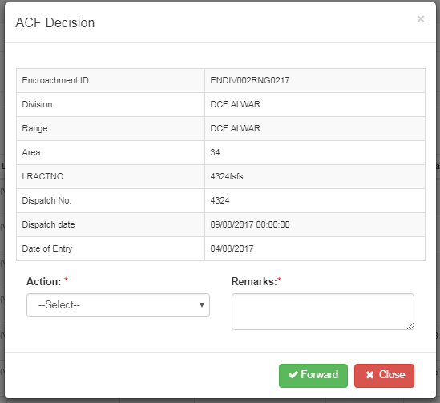

* ACF will select the “approve” option, system will display 2 more option: Notice No. and Notice Date.
* Notice No. should be auto generated.
* Notice Date should be current date.

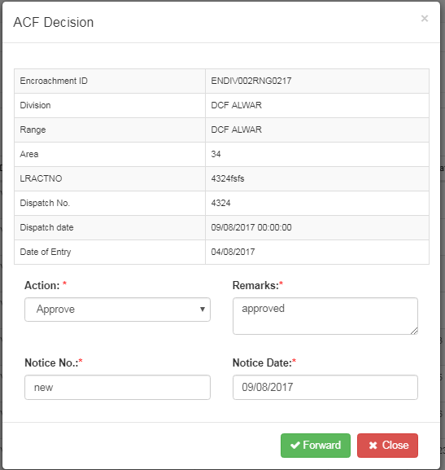

Once the notice is saved, then system should generate a message indicating to user that the record is successfully updated.

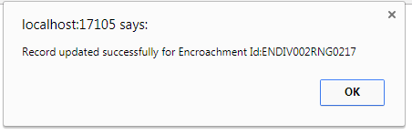

Notice generated through the application -

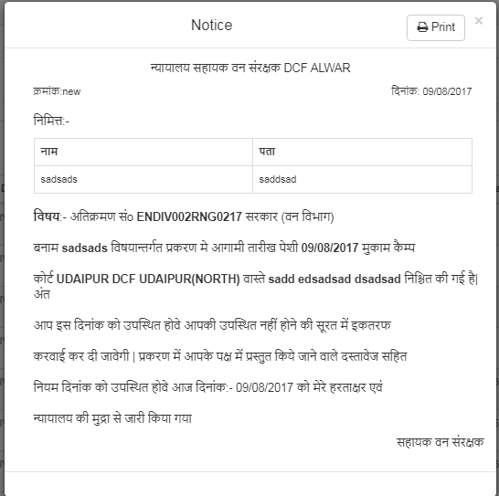

* System will also allow to print the generated notice.

Appearance form: With this form, ACF will select following option as a decision taken – Next date and Close.

* Once the decision is taken as “Next Date”, then a description needs to be entered andthe next appearance date needs to be selected.
* Once the decision is taken as “Close”, thena description needs to be entered.
* Once the decision is taken as either of the above, then a successful message should be generated to user.

Appearance window in case of “Next Date” as option -

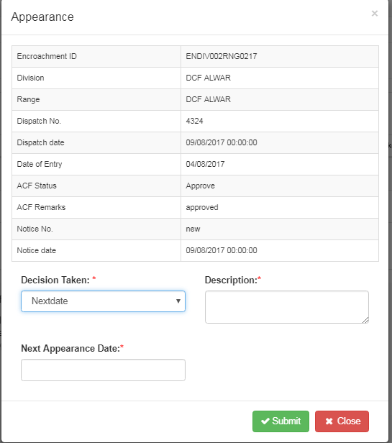

Appearance window in case of “Closed” as option -

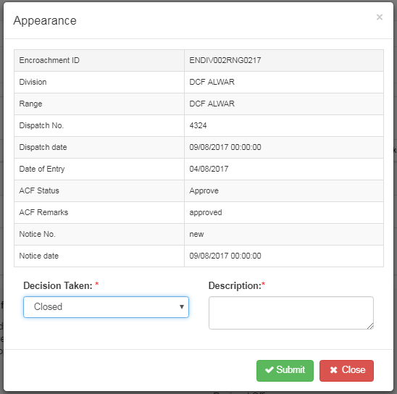

Successful submission message -

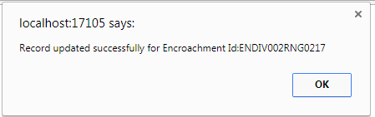

|  |  |
| --- | --- |
| Priority | Mandatory |
| User Characteristics | Citizen , Forest Officials (DFO , Assigned officer , ACF) |
| Operating Environment | ASP .Net MVC architecture with WCF service based integration |
| Design Constraints (if any) | NA |
| User Documentation | Will be more detailed in Design document and subsequent User Manual. |
| Project Inputs | RFP , Requirement Gathering and Client Interaction |
| Validations | Validations needs to be implemented as per the page. |
| Project Outputs | Web Application with related documentation and User Manual |
| *<Any Other>* | NA |

**<4>: Module Name*: <*Citizen Transit Permit*>***

Citizen Transit Permit module helps the citizen to apply for the permit of transit for the transport of the forest produce from one place to another within Rajasthan and to other state. Citizen who will apply will mostly be contractors/agencies/bidders.

Form of Transit Application by Citizen

Contractors/agencies/bidders after winning the bid, request for Transit Permit. They have to first make the payment after applying for Transit Permit.

TP contains following information in section:

1. Office Details
2. Applicant Details
3. Produce Details
4. Description of origin of forest produce for which the pass is valid
5. Vehicle Details
6. TP Movement Details

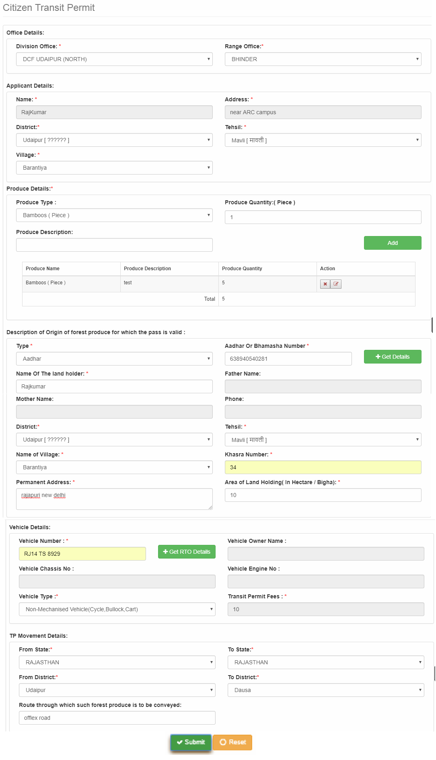

* The system will allow to add details of multiple forest produces.
* The system shall notify the Citizen about any error in the entered details of the configuration.
* The system shall notify the Citizen on successful submission of the application form.
* The system shall send sms /email notifications to the Citizen whenever there is a status update on the submitted application form.
* System will also allow to reset / cancel the enter details.
* In the above form, there are 2 integrations present – one is for getting details from Aadhar/Bhamashah after entering a valid Aadhar No. or Bhamashah. All the details which comes from this integration – will be saved in read only fields. Second one is RTO services, whereby entering a vehicle number, all the related details will appear.

Payment for Transit Permit from Citizen

* Once the details of the transit permit form will be submitted by citizen, it will open a new form called “Payment”, where payment of the transit permit will be calculated and displayed in a grid view with the other important details like Permit ID, Name, and Amount, Status.
* Once the user will click the Button “Pay Now”, the system will be redirected to “E-mitra” payment gateway, where the user can make the payment.
* Once the payment is successful, then this request will be forwarded to forester for review/approval process.

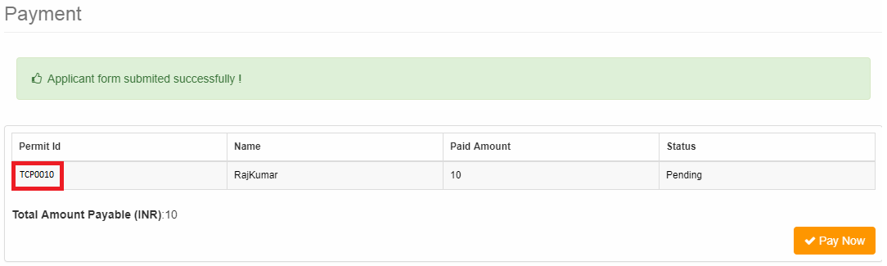

Login by Forester and View on Dashboard

* When the citizen make the successful payment, then his/her request will be forwarded to Forester (DFO).
* Once the forester login in the system, he/she can view all the pending request to be assigned in the Dashboard in the “To be assigned” link under Citizen services link.

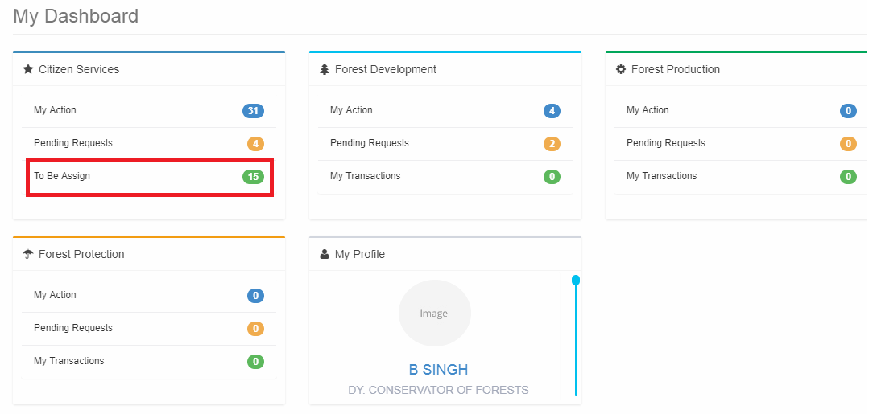

View the to be Assigned Application

* When the forester click the link “To be assigned”, it will open a new form of “Received Application”.
* This form have 3 tabs – “My Actions”, “Pending Requests” and “To be Assigned”. By default “To be Assigned” tab will be open displaying all the pending request to be assigned.
* User click the application to be assigned to open it.

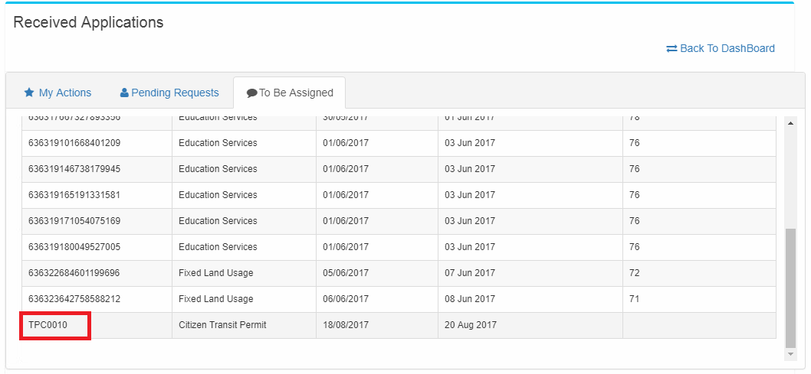

Assign the Transit Permit Application

* In the forward request details, all the details related to the application should be displayed and should be in only readable form.
* Once the Transit Permit application opens, there will be option to choose the “Designation” first.
* Once the designation is chosen, relative forest officer will be displayed in “Forest Officer” drop-down.
* Select a value in both the drop-down and when user clicks forward, then a forest official is assigned to this application.
* If a value is not selected in the “Designation” drop-down, then the related forest official should not display in the “Forest Officer”.
* If user selects the value in both the designation, and clicks close, then system should only close the form but do not assign a user.
* User can also click on print button to print the description of the information present on the form.

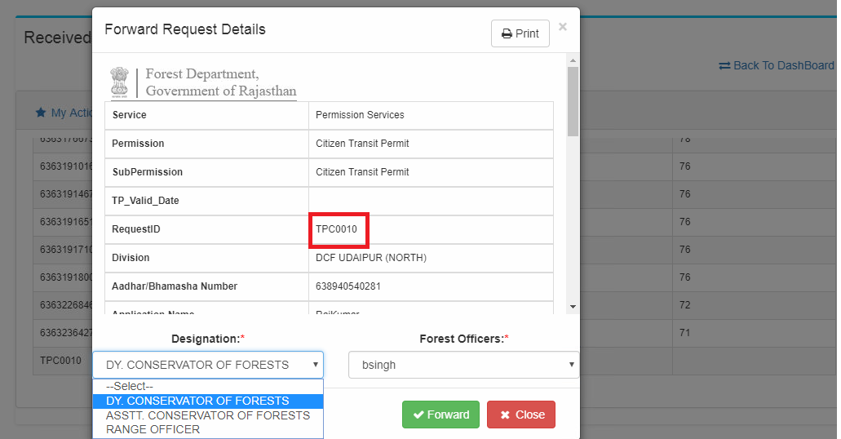

Application with Pending Inspection Date

* Once the application is assigned to the respective forest officials, then it will be displayed in the “Pending Request” tab of the assigned user.
* Assigned official will login in the application and go to the dashboard to click “Pending Requests” link.
* Pending request will be opened in the “Pending Request” tab.
* Application Status of this request will be “Pending Inspection Date”.
* Pending Inspection Date means an inspection date should be assigned to this application by the forest officials when this forest official will actually go and perform survey on this permit.
* If this will be a new request, then nothing should appear in “Pending since Days” column.
* Once the application is 24 hours old, then ‘1’ should appear in “Pending since Days” column.

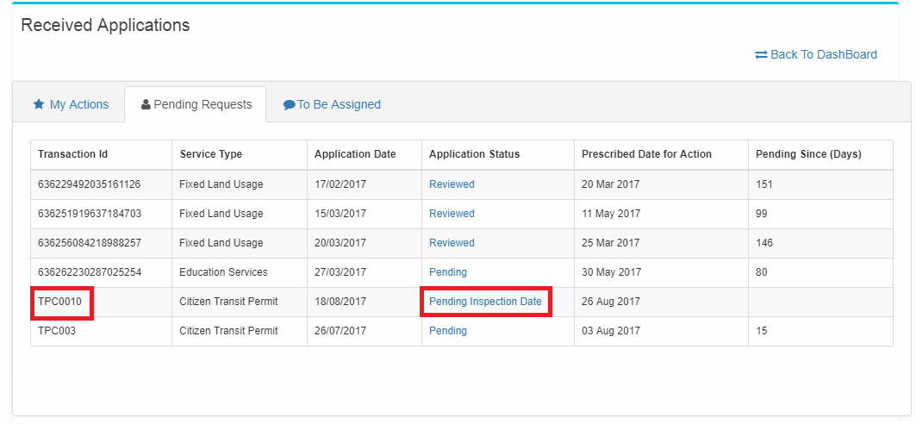

Adding the Inspection Date

* Application details will be displayed for selecting the Inspection Date and Time.
* Forest officials will select the date of Inspection and Time.
* User can perform forward and close functionalities.
* Once User select the Inspection Date and Inspection Time and click forward, this information will be saved under the received application with a new status on the dashboard.
* Once user clicks the close button, it will click close the respective form without saving.

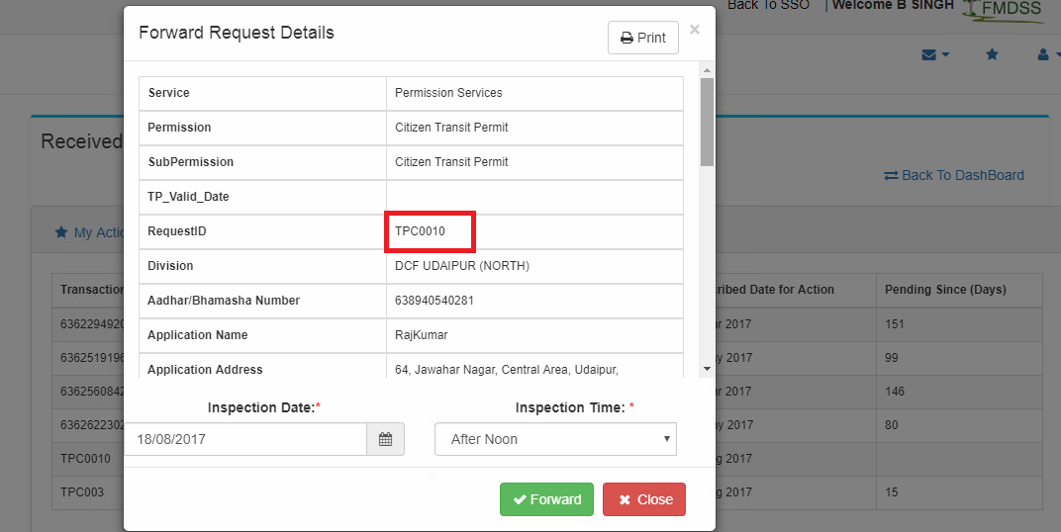

Application with Pending Inspection Report

* Once the forest official select the Inspection date and time and click forward , then this information will be saved under the received application with a new status “Pending Inspection Report” on the dashboard.
* User will click this status in the record to open “Survey Report Form”.

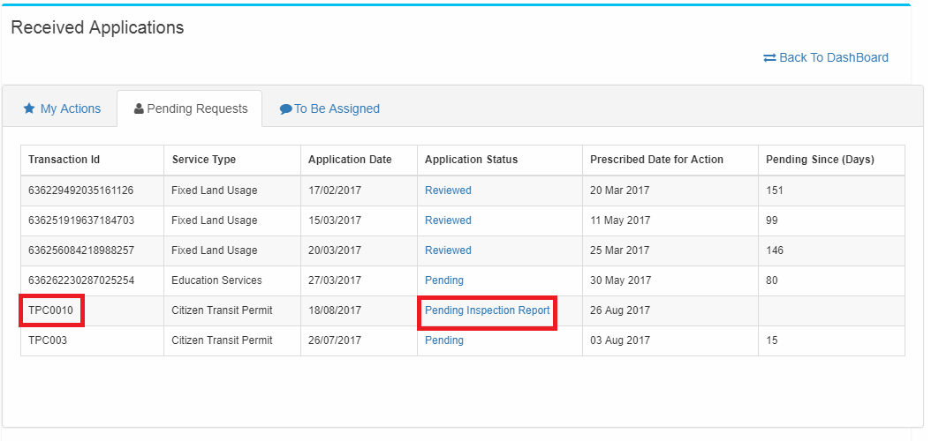

Survey Report

Under this form, forest official will enter details in following section:

* Office Details
* Produce Details
* Survey Details
* User will have option of adding details of multiple forest produce in the form.
* The adding of multiple forest produces is temporary and will not be saved if reset/cancel button is clicked.
* Delete/view functionality is also provided for deleting and view the added forest produce.
* User will be able to upload Survey photo of up to size of 2 MB.
* System will also allow to reset / cancel the enter details.

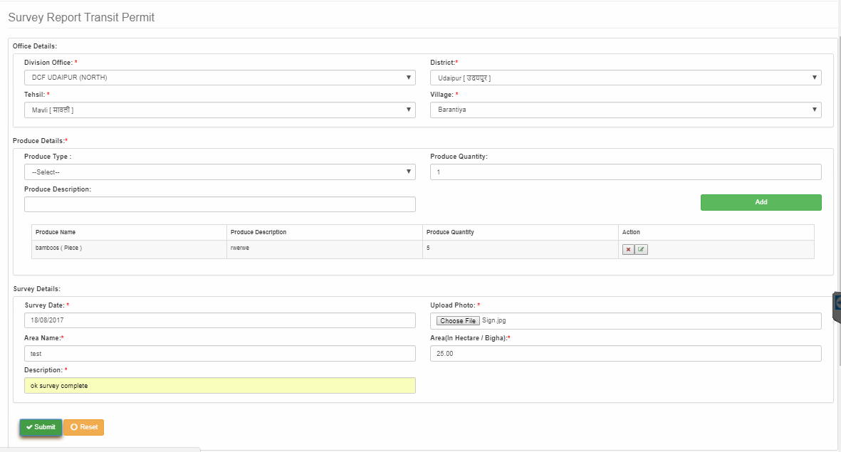

Application to be Reviewed and Approved -

* Once the Forest official will submit the survey, then the status of the application is changed to “Pending” status.
* The “Pending” status can be view under Received Application -> Pending Requests.

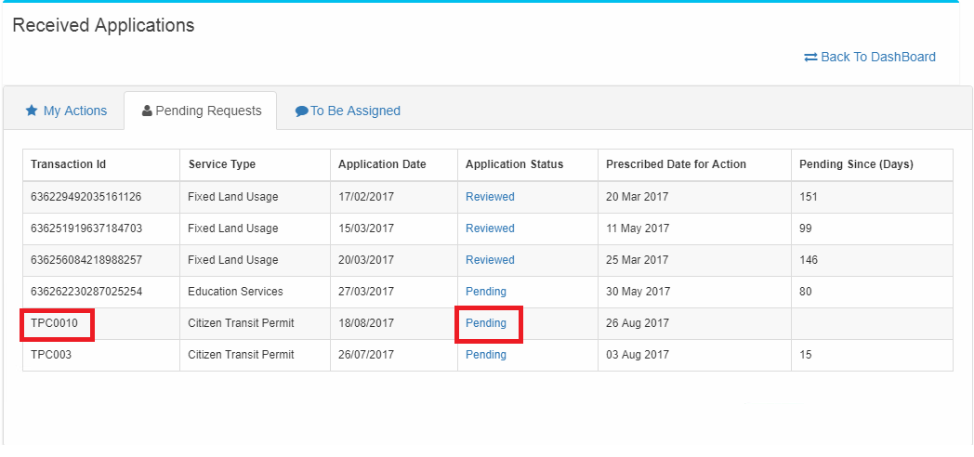

Review/Approve the request

* Now forest official can review/approve the application based on the Survey Input.
* Reviewer will upload the Inspection /Verification Report.
* Reviewer/Approver will add their respective comments.
* Reviewer/Approver can approve/reject the application after entering their respective comments.
* Reviewer/Approver can view the details of the application by clicking “View Request Details”.
* Once the application is approved/rejected, then a sms/email will be forwarded to the citizen requesting the application.

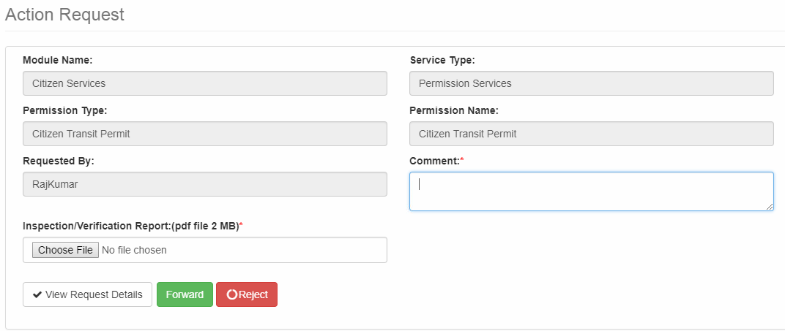

|  |  |
| --- | --- |
| Priority | Mandatory |
| User Characteristics | Citizen , Forest Officials (DFO , Assigned officer) |
| Operating Environment | ASP .Net MVC architecture with WCF service based integration |
| Design Constraints (if any) | NA |
| User Documentation | Will be more detailed in Design document and subsequent User Manual. |
| Project Inputs | RFP , Requirement Gathering and Client Interaction |
| Validations | Validations needs to be implemented as per the page. |
| Project Outputs | Web Application with related documentation and User Manual |
| *<Any Other>* | NA |

## **Operational Requirements**

*<If section not applicable, indicate so and provide a reason>*

*<Define details of hardware, software, network bandwidth, data center, drivers, operating environment, IT security, infrastructure needs etc. at user environment>*

**Development Environment:** Below is the schematic diagram of the development environment

Proposed by RISL based on existing infrastructure.

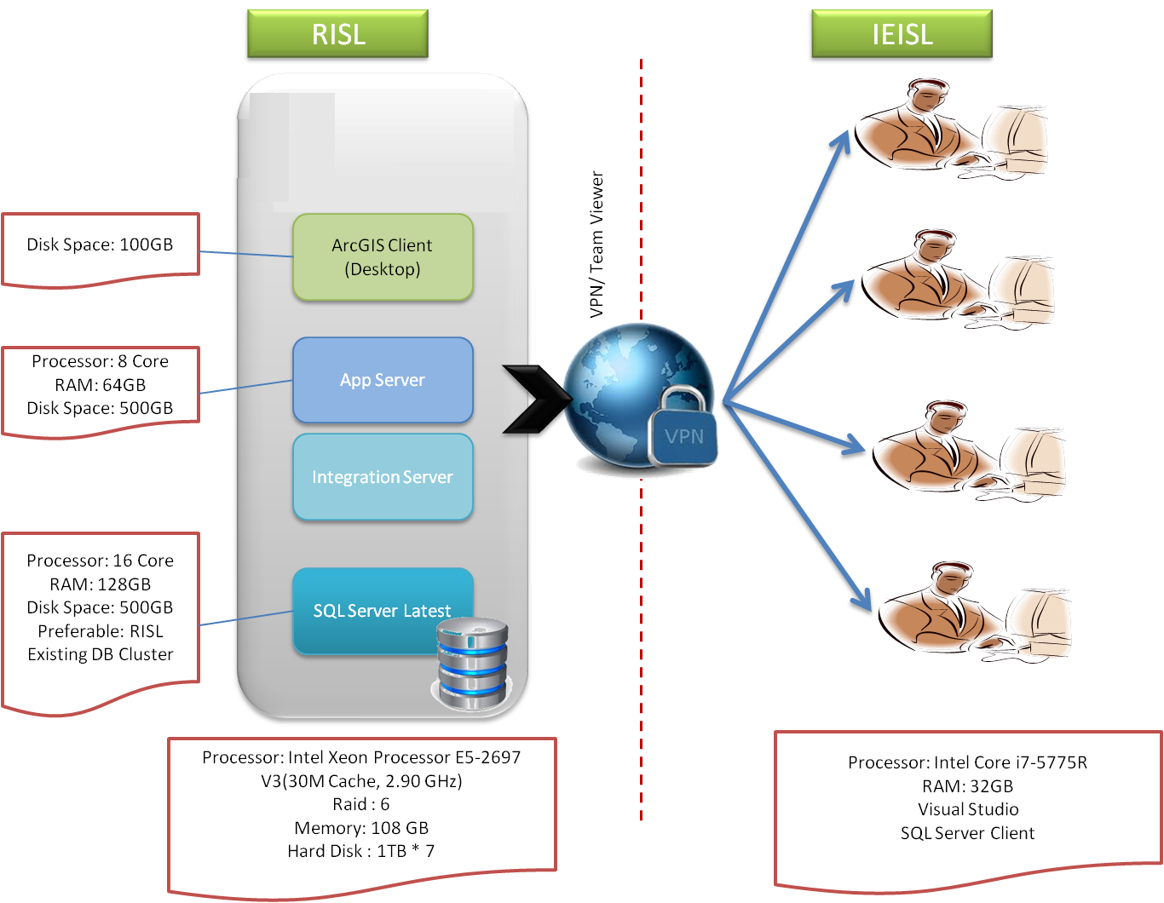

Details of licenses required is as follows:

|  |  |  |  |
| --- | --- | --- | --- |
| **S. No** | **Asset Name** | **Configuration Required** | **Software** |
| **Production Server** | | | |
| 1 | Web Server (Qty-1) | Processor: 44 Cores RAM: 512GB | IIS , ArcGIS Web Adaptor 10.2 |
| 2 | App Server (Qty-1) | Processor: 44 Cores RAM: 512GB | Microsoft Windows Server 2012 R2, IIS v8.5 |
| 3 | Database Server | Existing from RSDC | Microsoft Windows Server 2012 R2, SQL Server  Enterprise 2014 (1+1) |
| **Development Server** | | | |
| 1 | Development Machines at IEISL | Processor: Intel Core i7-5775R RAM: 32GB, Visual Studio SQL Server Client, Windows 8 |  |
| 2 | GIS Client | Existing from RSDC | ArcGIS Client (Qty-1) |
| 3 | Data Base Server | Existing from RSDC | SQL Server  Enterprise 2014 (Qty-1) |
| 4 | Web & APP Server | Existing from RSDC | MS-Windows Server 2012 R2 with IIS 8.5 |

## **Software Quality Attributes**

*<Describe the quality parameters like performance, transaction levels, consistency, up-time, software availability, server availability, number of concurrent user etc.>*

It is being decided maximum 5000 concurrent user hitting the website. The average response time for the page view at datacenter level is 30 sec.

The system is proposed to be integrated with existing 15 systems/applications. Any time lag/delay caused in the existing systems will lead to overall delay in the application output.

## **Non-Functional Requirements**

|  |  |
| --- | --- |
| Security | **NA** |
| Safety | **NA** |
| Cultural | **Application support Hindi and English. The inputs fields shall be English** |
| Political | **NA** |
| Performance | **Applications performance will be datacenter level with 30 sec render time.** |
| Penalty Clause | **Penalty for Non-performance in required Service Levels/ Standards** |

## **Scalability Requirements**

NA

## **External Interfaces**

### **User Interfaces**

<Describe the logical characteristics of each interface between the software, data and the users. This may include sample screen images, any GUI standards or software style guides that are to be followed, screen layout constraints, standard buttons and functions (e.g., help) that will appear on every screen, keyboard shortcuts, error message display standards, and so on. Define the software and data components for which a user interface is needed. Details of the user interface design should be documented in the design document.>

### **Hardware Interfaces**

<Describe the logical and physical characteristics of each interface between the software, data and the hardware components of the system. This may include the supported device types, the nature of the data and control interactions between the software and the hardware, and communication protocols to be used.>

### **Software Interfaces**

<Describe the connections between the required software and other specific software components (name and version), including databases, operating systems, tools, libraries, and integrated commercial components. Identify the data items or messages coming into the system and going out and describe the purpose of each. Describe the services needed and the nature of communications. Refer the documents that describe detailed application programming interface protocols. Identify data that will be shared across software components. If the data sharing mechanism must be implemented in a specific way, specify this as an implementation constraint (for example, use of a global data area in a multitasking operating system).>

### **Communications Interfaces**

<Describe the requirements associated with any communications functions required by the software and data components, including e-mail, web browser, network server communications protocols, electronic forms, and so on. Define any pertinent message formatting. Identify any communication standards that will be used, such as FTP or HTTP. Specify any communication security or encryption issues, data transfer rates, and synchronization mechanisms.>

**Integration with Existing System:**

Integration with SSO:

* This application helps the user to login only once for accessing various application
* This application is already up and running at RSDC and is required to be integrated for FMDSS
* It is based on LDAP model
* User management and access control mechanism will be based on single sign on

Integration with E-sign Services:

* All the approved application/NOC given by the Forest Department should be digitally signed by the respective forest authority.
* Once the application/NOC is approved, the department user will add their e-signature.
* For adding e-signature, Department user will verify their signature by adding Aadhar card and the system will validate their e-signature based on their validity of Aadhar Card.
* The output from the integration will be Signed document, Response Code and Error Message, if any.

Integration with Refund API

* In online ticketing module , for all the booking done in advance may lead to return of the **half** of the ticket price amount if the ticket cancellation is done before 1 month of date of actual date of using the ticket.
* Government will returned the half price of the ticket amount.
* The output from this integration will be a message “Transaction Cancelled Successfully”, Status and error message, if any.

Integration with Master Data Web Service:

* With the help of this master data web service, various master data can be updated as indicated below in the list of Master Data.
* This will update the master data present in FMDSS system.

List of Master Data exposed through Web-Service with their Master Data ID

|  |  |  |
| --- | --- | --- |
| Master Data ID | Master Data Name | Description |
| 1 | BDH_BANK | Bank Master |
| 2 | BDH_BANK_BRANCH | Bank Branch Master |
| 3 | BDH_CITY | City Master |
| 4 | BDH_WARD | Ward Master |
| 5 | EMITRA_ACCOUNT_TYPE | Account Type Master |
| 6 | EMITRA_COUNTRY | Country Master |
| 7 | EMITRA_FIN_YEAR | Financial Year Master |
| 8 | EMITRA_GENDER | Gender Master |
| 9 | EMITRA_HOLIDAY | Holiday Master |
| 10 | EMITRA_JURISDICTION | Jurisdiction Master |
| 11 | EMITRA_JURISDICTION_LEVEL | Jurisdiction Level Master |
| 12 | EMITRA_JURISDICTION_TYPE | Jurisdiction Type Master |
| 13 | EMITRA_MOTHER_TONGUE | Mother Tongue Master |
| 14 | EMITRA_MUNICIPALITY_TYPE | Municipality Master |
| 15 | EMITRA_OCCUPATION | Municipality Type Master |
| 16 | EMITRA_OFFICE_TYPE | Office Type Master |
| 17 | EMITRA_STATE | State Master |
| 18 | IHRMS_ADMIN_DEPT | Admin Department Master |
| 19 | IHRMS_AWARDLEVEL | Award Level Master |
| 20 | IHRMS_CADRE | Cadre Master |
| 21 | IHRMS_CASTE | Caste Master |
| 22 | IHRMS_CATEGORY | Category Master |
| 23 | IHRMS_COURT | Court Master |
| 24 | IHRMS_CRITICAL_DISABILITY | Critical Disability Master |
| 25 | IHRMS_CRITICAL_ILLNESS | Critical Illness Master |
| 26 | IHRMS_DDO_INFO | DDO Info Master |
| 27 | IHRMS_DEGREE_TYPE | Degree Type Master |
| 28 | IHRMS_DEPARTMENT | Department Master |
| 29 | IHRMS_DESIGNATION | Designation Master |
| 30 | IHRMS_LANGUAGE | Language Master |
| 31 | IHRMS_LEAVE | Leave Master |
| 32 | IHRMS_MARITAL_STATUS | Marital Status Master |
| 33 | IHRMS_OFFICE | Office Master |
| 34 | IHRMS_OFFICE_HIERARCHY | Office Hierarchy Master |
| 35 | IHRMS_OFFICE_LEVEL | Office Level Master |
| 36 | IHRMS_PAYCOMMISION | Pay Commission Master |
| 37 | IHRMS_PAYSCALE | Pay Scale Master |
| 38 | IHRMS_POST | Post Master |
| 39 | IHRMS_PROFESSION | Profession Master |
| 40 | IHRMS_QUALIFICATION_DEGREE | Qualification Degree Master |
| 41 | IHRMS_QUALIFICATION_LEVEL | Qualification Level Master |
| 42 | IHRMS_QUALIFICATION_SUBJECT | Qualification Subject Master |
| 43 | IHRMS_QUALIFICATION_UNIVERSITY | Qualification University Master |
| 44 | IHRMS_QUOTA | Quota Master |
| 45 | IHRMS_RELATION | Relation Master |
| 46 | IHRMS_RELIGION_NAME | Religion Master |
| 47 | IHRMS_SERVICE | Service Master |
| 48 | IHRMS_SERVICE_SELECTION | Service Selection Master |
| 49 | IHRMS_SERVICE_TYPE | Service Type Master |
| 50 | IHRMS_STATUS_TYPE | Status Type Master |
| 51 | IHRMS_TITLE | Title Master |
| 52 | IHRMS_TRANSFER_TYPE | Transfer Type Master |
| 53 | IHRMS_TREASURY | Treasury Master |
| 54 | IHRMS_TYPE_OF_SERVICE | Type of Service Master |
| 55 | PRAJ_BLOCK | Block Master |
| 56 | PRAJ_DISTRICT | District Master |
| 57 | PRAJ_DIVISION | Division Master |
| 58 | PRAJ_GP | GP Master |
| 59 | PRAJ_VILLAGE | Village Master |
| 60 | RVNU_ILR | ILR Master |
| 61 | RVNU_PATWAR | Patwar Master |
| 62 | RVNU_TEHSIL | Tehsil Master |
| 63 | CITY_TYPE | City Type Master |
| 64 | ELECTION_AC | Assembly Constituency |
| 65 | ELECTION_DISTRICT_AC_PC | District Assembly Constituency / Parliament Constituency Mapping |
| 66 | ELECTION_PC | Parliament Constituency Master |
| 67 | POPULATION_BLOCK | Block Population Master |
| 68 | POPULATION_CITY | City Population Master |
| 69 | POPULATION_VILLAGE | Village Population Master |
| 70 | SD_TEHSIL | Sub Division Tehsil Mapping |
| 71 | SUB_DIVISION | Sub Division Master |
| 72 | SUB_TEHSIL | Sub Tehsil Master |

# System Data Requirements

*<This section covers detailed system requirement study of data development.>*

## **Data Module Requirement**

*<If section not applicable, indicate so and provide a reason>*

**<Number>: Module Name*: <Name>***

*<Define various type of data modules, example: Land-use & Land-cover (LU/LC), Ortho-photo Generation, Digital Terrain Model (DTM), Digital Elevation Model (DEM), 3-D City Models, Infrastructure Data Modules etc. which shall also include data conversion and migration and interface requirements.>*

|  |  |
| --- | --- |
| Priority | *<Mention the priority for this module/functionality. This is to be decided based on urgency and dependency like - Priority 2, this module can only start after completion of Monumentation>* |
| Operating Environment | *<RDBMS platform, Software platform, Operating System Open Source based etc. >* |
| Design and Development Constraints (if any) | *<Out of box requirement not supported by data development and data creation. Example: Creation of 2 meter accuracy level of contour lines from 2.5 meter stereo pair of satellite data.>* |
| User Documentation | *<Data related client documentation like: specific data design, reference data model, sample data, user guide, data standards etc.>* |
| Project Inputs | *<Mention all project inputs>* |
| Validations | *<Mention required Validations>* |
| Project Outputs | *<Mention all project outputs>* |
| *<Any Other>* |  |

## **Data Architecture**

<*Data development architecture includes description of high level data structure and layer composition, data model including specific customized data attributes, meta-data structure, data technical specifications including technology aspect etc.>*

## **Operational Requirements**

*<Define details of hardware, software, network bandwidth, data center, software drivers, operating environment, IT and data security, Infrastructure needs etc. at customer environment for the complete data development activity.>*

## **Data Quality Attributes**

*<Describe the quality parameters like Data Accuracy, Data Consistency, Image Quality, Map Quality, Properties and Projection Parameters, RMSE Value, Specific Data Quality Standards etc.>*

## **Non-Functional Requirements**

|  |  |
| --- | --- |
| Security | *<Non-Disclosure Agreement,*  *Encryption Technology, IPR, Copyright, Licensing etc.>* |
| Safety | *<Data Confidentiality, Safe storage and archiving, Backup, Controlled Access etc.>* |
| Cultural | *<Bilingual etc.>* |
| Political |  |
| Data Back-up and Restoration | *<CD Storage, tape libraries, file server>* |
| Team Discipline | *<in case of survey project, Punctuality, adherence to working norms on field>* |
| Skilled Resources | *<Hands on Training on Equipment>* |
| Equipment in Working Condition | *<DGPS equipment should be calibrated and should be giving correct observations>* |
| Business Rules | <List any operating principles about the system, such as which individuals or roles can perform which functions under specific circumstances. These are not functional requirements in themselves, but they may imply certain functional requirements to enforce the rules.> |
| *<Any Other>* |  |

## **Scalability Options**

*<If section not applicable, indicate so and provide a reason>*

*<Define any data specific enhancement requirement identified during URS. Example: Additional data coverage (Horizontal Scalability), enhancement in data model, data attributes and its derivatives (Vertical Scalability).>*

# System Service Requirements

*<If section not applicable, indicate so and provide a reason>*

<Warranty, AMC, Training, Support & Services (SLA) requirement shall be mentioned in this section.>

Application support for 1 years as service and training of the Forest Department users. AMC has a pre-defined SLA (as per RFP) excluding hardware supply.

# Usage Concept

*<Specify which actors shall interact with the system and how they have to interact to achieve their intended usage goals.>*

## **User Roles**

*<Define all the users along with their roles who shall access the system. Mention their authorization and authentication requirements. Define their access related limitation, if any.>*

## **Use CASE 1. <Name>**

|  |  |
| --- | --- |
| Goal | *<A goal briefly describes what the user intends to achieve with this use case. One or two sentences should be sufficient.>* |
| Actors | *<Specify the actors involved in this particular use case.>* |
| Preconditions | *<Specify the pre-conditions which are important to be true before this use case occurs.>* |
| Main Flow | *<Outline the typical sequence of interactions between use case actors and the system and their actions to achieve the use case goal (also called “normal flow”).*  *Describe alternative system states after the use case is done. Consider normal and alternative flows.>* |
| Post-conditions | *<Specify the post conditions applicable on this particular use case.>* |
| References | *<Specify the references used while developing this use case.>* |

# Miscellaneous Requirements

*<Define miscellaneous requirements as provided by the customer in the following table.>*

|  |  |
| --- | --- |
| Legal and Regulatory | *<IT act, Security Laws, State Laws, Data Privacy Law etc.>* |
| Allocated Requirements | **Number of allocated requirement is High** |
| Collaboration/Consortium | *<if any>* |
| Logistics Requirement | *<if any>* |
| Inventory Management | *<if any>* |
| *<Any other>* |  |

# Exclusions NA

*<Mention the user requirements which have been excluded during the preparation of SRS with reasons.>*

## **<Requirement 1>**

* + 1. **Description**

*<Requirement Description>*

* + 1. **Exclusion Type**

*<Deferred or non-feasible>*

* + 1. **Reason for exclusion**

*<Detailed description of the reason for exclusion>*

* + 1. **Reference to Annexure or documents**

*<Refer documents or annexure listings which will support the above reason>*

# Assumptions and Dependencies

<*Mention all the assumptions and dependencies made during the preparation of the SRS document.>*

Assumptions –

1. It is assumed that all the existing applications with RISL are fully functional
2. It is assumed that all the existing applications with RISL are customizable and allow integration with the envisaged application
3. It is assumed that any scope not mentioned in the RFP will be treated as Change of scope and subject to additional cost and time.

Dependencies -

There are following dependencies observed:

1. Collection of input data from forest department
2. Availability of concerned stakeholders on short notice (considering the aggressiveness project schedule)
3. Availability of SME who knows and can share the complete process. Lot of time consumed in interacting stakeholders of various departments
4. Nonfunctional requirement of the application.
5. Number of concurrent user accessing to the application.
6. Since the application dependent to different integration points, problem in other system impact overall SLA.

# To Be Determined List

*<Collect a numbered list of the TBD (to be determined) references that remain in the SRS so they can be tracked to closure.> NA*

# Appendix

*<Mention all the supporting documents referred throughout the SRS document.>*

RFP, Requirement document shared by Consultant team and Format shared by Forest Department

# Glossary

*<Define the terms and acronyms used throughout the SRS document for better understanding and clarity.>*

|  |  |
| --- | --- |
| Abbreviations/Terms | **Definition** |
| SRS | System Requirement Specification |
| IT | Information Technology |
| AMC | Annual Maintenance Contract |
| SLA | Service Level Agreement |
| URS | User Requirement Specification |
| RMSE | Root Mean Square Error |
| RDBMS | Relational Database Management System |
| COTS | Commercial Off The Shelf |
| MVC | Model View Controller |
| TBD | To Be Decided |
| SOA | Service Oriented Architecture |
| GUI | Graphical User Interface |
| IPR | Intellectual Property Rights |
| DFO | Division Forest Officers |
| SHQ | State Head Quarter |
| CCF | Chief Conservator of Forest |
| PCCF | Principal Chief Conservator of Forest |
| IFMS | Integrated Financial Management System |
| DMS | Document Management System |
| JFMC | Joint Forest Management Committee |
| VFPMC | Village Forest Protection Management Committee |
| DMS | Document Management System |